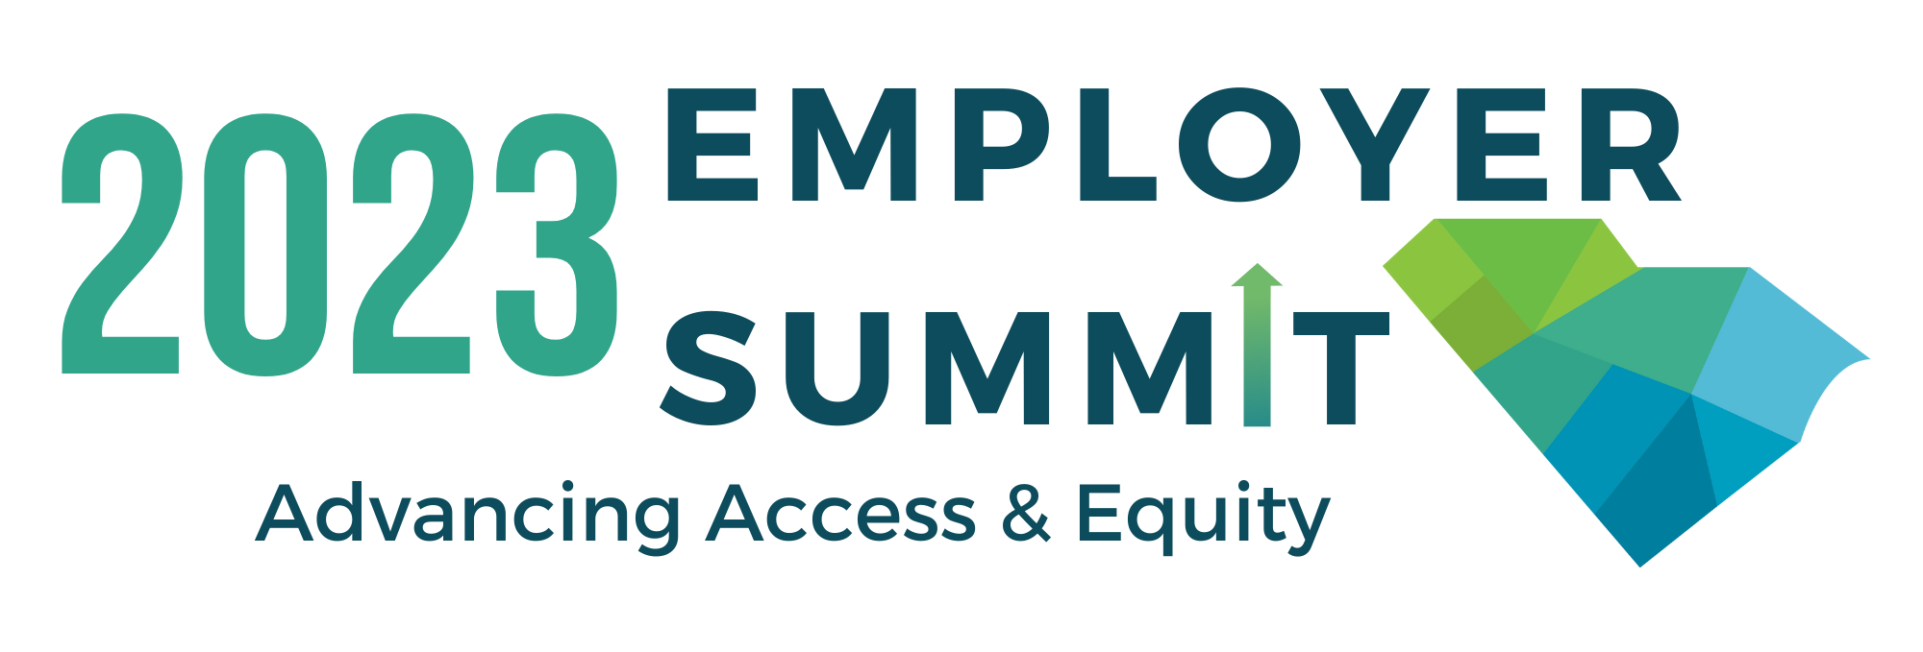

2023 Employer Summit Vendor Information

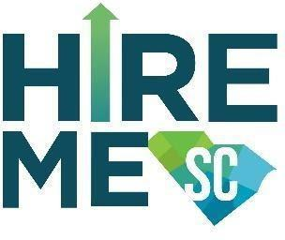

Hire Me SC
Hire Me SC is a campaign that promotes a culture of inclusion across South Carolina, in which employment for every individual, disability or not, is the norm rather than the exception. The campaign offers training to employers, technical assistance, and the opportunity to participate in the Business Coalition, a peer-to-peer business mentoring group.
Contact: Marly Saade, Director of Employment Programs at Able SC
Phone: 800-681-6805
Email: hiremesc@able-sc.org
Website: www.hiremesc.org
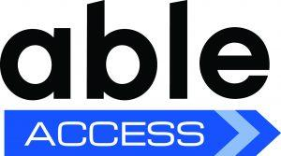

Able Access
Providing full access to your customers is not only the law, it’s also good business. Able Access offers the following services to assist you with giving access to people with disabilities: on-site accessibility survey, policy & procedure review, online accessibility review, and customized professional training.
Contact: Mary Reaves, Director of Community Access at Able SC
Phone: 800-681-6805
Email: advocacy@able-sc.org
Website: www.able-sc.org/get-support/accessibility-consultations/
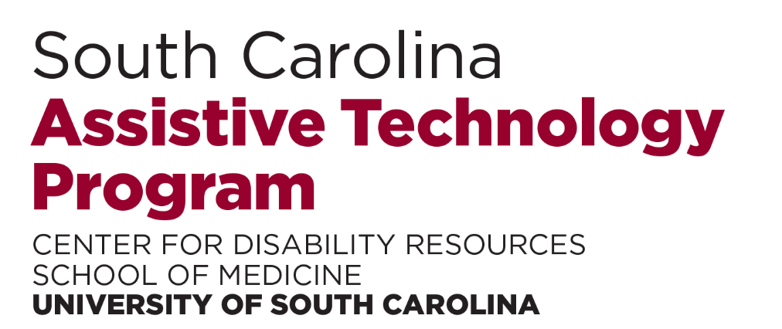

The South Carolina Assistive Technology Program (SCATP)
SCATP uses technology devices and services to help people with disabilities live, work, and learn more independently. SCATP staff members assist agencies that employ or are involved with individuals with disabilities. We help agencies and businesses make their services accessible and compliant with federal and state statutes governing access by people living with disabilities.
Contact: Tammy Wallace, Program Coordinator
Phone: 803-935-5263
Email: tammy.wallace@uscmed.sc.edu
Website: sc.edu/medicine/scatp

Apprenticeship Carolina
Apprenticeship Carolina™, a division of the SC Technical College System, leads South Carolina in registered apprenticeship programs that help businesses and communities thrive economically. Through innovation, partnerships, and a spirit of excellence, Apprenticeship Carolina catalyzes the promotion of registered youth, adults, and pre-apprenticeships. Apprenticeship Carolina is also a resource to help employers create, maintain, and maximize the use of these programs. Apprenticeship Carolina is committed to creating and strengthening career pathways that enrich and enhance South Carolina’s existing and future workforce.
Contact: Brittany Salley, Apprenticeship Consultant
Phone: 803-205-5409
Email: salleyb@sctechsystem.edu
Website: https://www.apprenticeshipcarolina.com/about.html
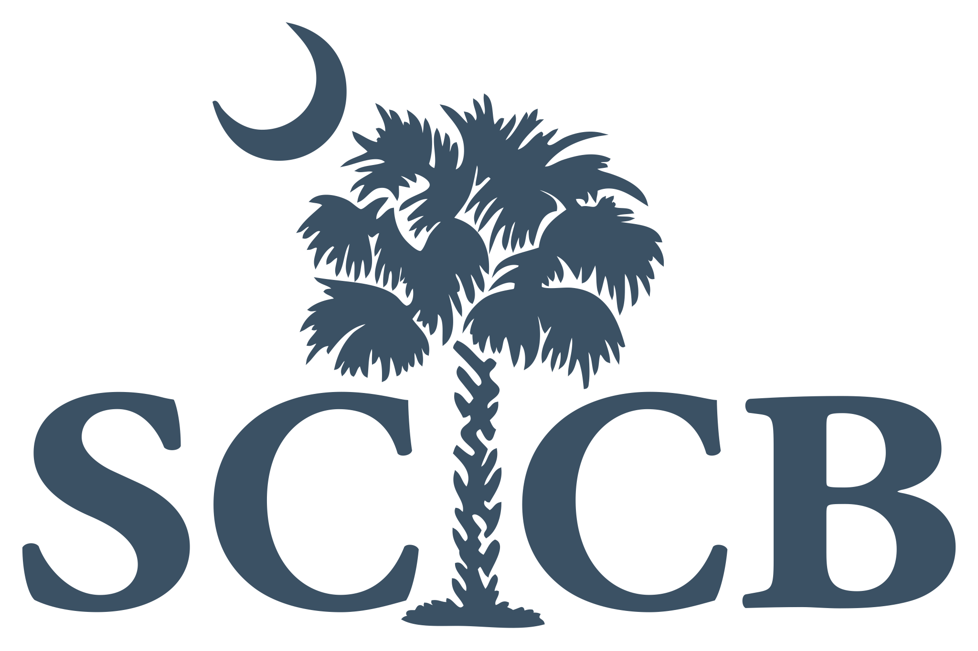

South Carolina Commission for the Blind
The SC Commission for the Blind provides an untapped labor pool of qualified candidates to support employers with recruitment and diversifying their workforce. SCCB also provides information and support services, inclusive workplace training, on-the-job training, work-based learning, internship arrangements, and assistance with applying for the Work Opportunity Tax Credit (WOTC) for businesses.
Contact: Luis Mendoza, Human Resources Director
Phone: 803-530-5017
Email: Luis.mendoza@sccb.sc.gov
Website: www.sccb.state.sc.us

South Carolina Department of Mental Health, IPS Program
The South Carolina Department of Mental Health (SCDMH) is a state agency whose mission is to support the recovery of people with mental illnesses. Essential components to recovering from mental illnesses are housing and employment. Individual Placement and Support (IPS) is a statewide collaborative supported employment service between SCDMH and the SC Vocational Rehabilitation Department. IPS Employment Specialists and VR Job Coaches provide IPS services to anyone with a mental illness who expresses a desire to work and is enrolled in one of DMH’s agencies.
Contact: Treca DeShields, IPS Supervisor - Greater Greenville Mental Health
Phone: 864-933-6343
Email: Treca.deshields@scdmh.org
Website: https://scdmh.net/
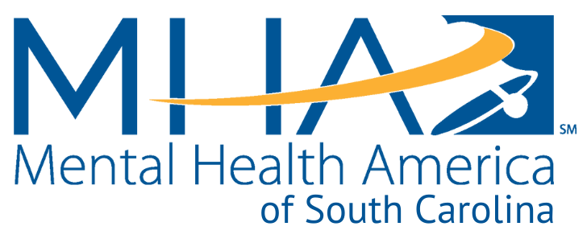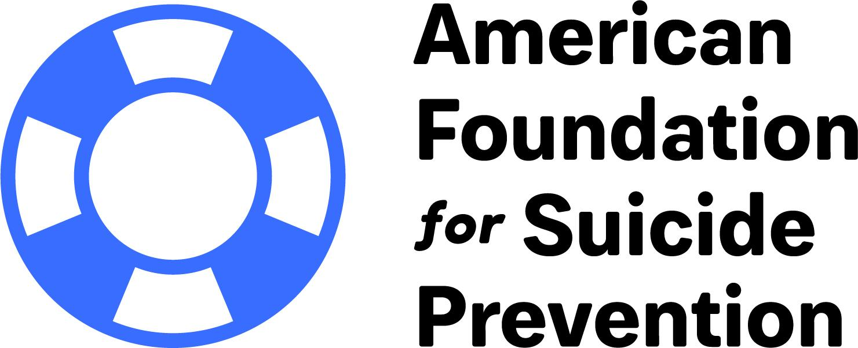

Mental Health America of SC & American Foundation for Suicide Prevention-SC
Through advocacy, education, research, and service, Mental Health America of South Carolina works to improve the lives of people with mental illness in South Carolina, promote mental health, prevent mental disorders, and achieve victory over mental illness. The American Foundation for Suicide Prevention’s South Carolina chapter does grassroots work that focuses on eliminating the loss of life from suicide by delivering innovative prevention programs, educating the public about risk factors and warning signs, raising funds for suicide research and programs, and reaching out to those individuals who have lost someone to suicide.
Contact: Eileen Schell, Community Resource Coordinator, MHA of SC and Chair, AFSP-SC Board
Phone: 803-920-1487
Email: eschell@mha-sc.org
Website: https://www.mentalhealthamerica-sc.com & https://afsp.org/chapter/south-carolina
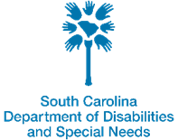
Department of Disabilities and Special Needs
The mission of the South Carolina Department of Disabilities and Special Needs is to assist individuals with an Intellectual Disability or a Related Disability, Autism Spectrum Disorder, Traumatic Brain Injury, Spinal Cord Injury, and Similar Disability and their families through choice in meeting needs, pursuing possibilities and achieving life goals; and minimize the occurrence and reduce the severity of disabilities through prevention.
Contact: Becky Peters, Director of Adult Supports
Phone: 803-898-9704
Email: becky.peters@ddsn.sc.gov
Website: https://ddsn.sc.gov
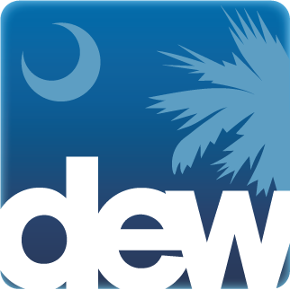
South Carolina Department of Employment and Workforce
The mission of the South Carolina Department of Employment and Workforce is to promote and support an effective, customer-driven workforce system that facilitates financial stability and economic prosperity for employers, individuals, and communities. SCDEW is a partner in the state’s workforce system, which includes SC Works Centers. In partnership with SCDEW, SC Works provides all job seekers with career counseling, job referrals, testing and training services, job readiness workshops, and resume-writing assistance.
Contact: Amy Hill, WOTC and Federal Bonding Manager
Phone: 803-737-3228
Email: ahill@dew.sc.gov
Website: https://dew.sc.gov/

